Data Michiana Notre Dame Rental Housing Analysis

The University of Notre Dame is currently the largest employer in St. Joseph County. With that being said, the increased gentrification around the university is forcing its employees and students to search for affordable housing farther and farther away from campus. Employees who were once able to walk to their job are now required to find a reliable means of transportation or pay the increased rate of housing to live close to campus. This issue is putting a bind on the employees. Even though the pay for campus employees has increased, this increase is not enough to match the increased cost of living close to campus. The battle for affordable housing for employees doesn’t end there. Not only are the employees battling the increased housing costs, but they are also having to compete with Notre Dame students on securing the available housing. Being that the Notre Dame student median household income tends to be much higher than that of Notre Dame employees it causes the rental properties to favor the students. The rental companies are able to charge students more for rent than the employees.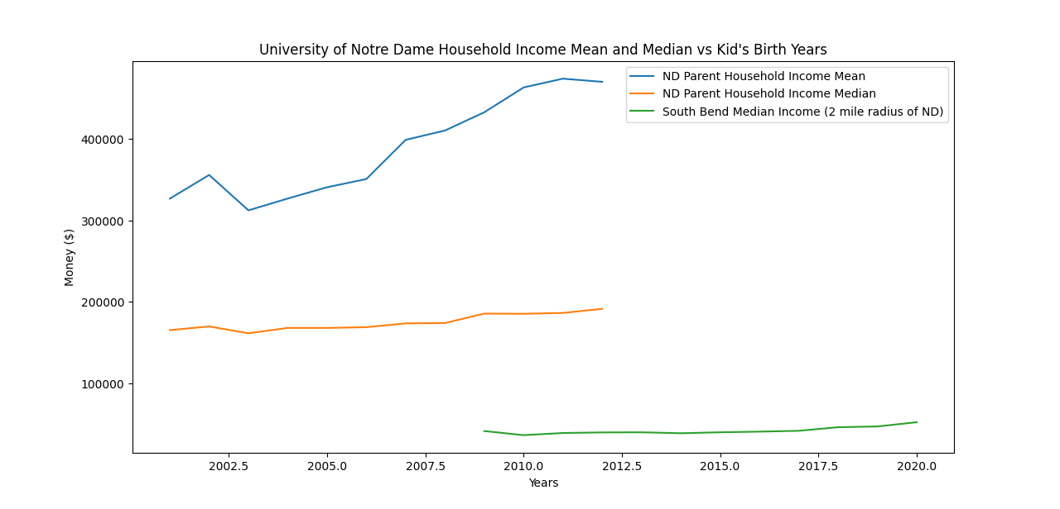

Figure 1

All Notre Dame students are required to live on campus for their first 6 semesters. Room and board are not cheap, especially when compared to the price of living off campus. Currently, for the 2022-23 school year, the cost of room and board on campus is $16,710. When compared to the cost of living on campus ($8,880 for rent and $2,318 for food) it comes out to about a $5,500 saving for those who live on campus. However, as seen by the chart below the increased cost of living for off-campus housing is shrinking the cost savings year after year. 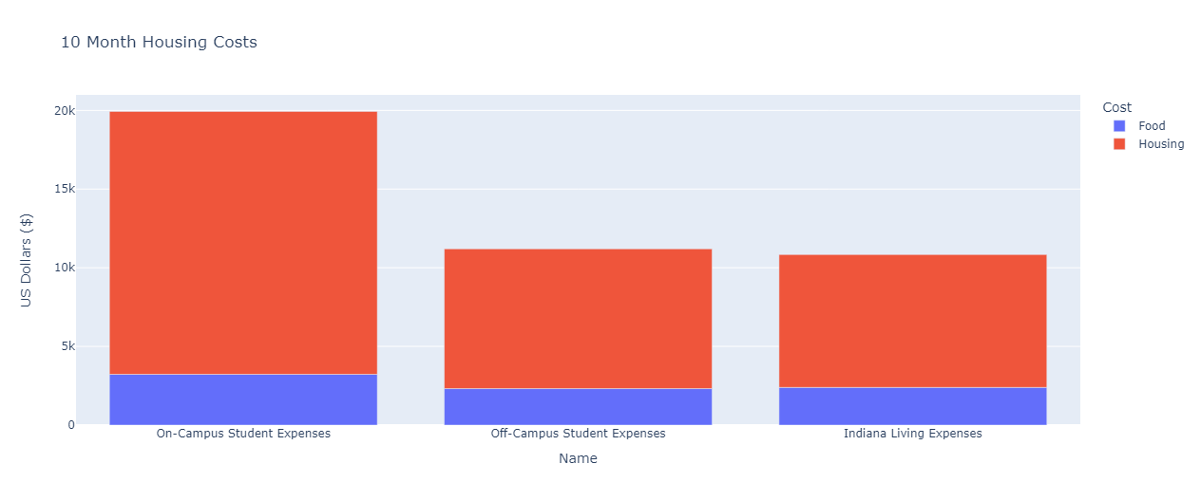

Figure 2

As shown, Off-Campus living expenses are very similar to that of the average Indiana living expenses, if not slightly more expensive. Such a significant disparity between On-Campus living and Off-Campus living makes it so that many students may be encouraged to move into rental housing in order to save up to nearly ten thousand dollars between food and housing. Note, however, that this graphic does not account for other things that come along with living Off-Campus such as transportation and rental insurance. With this disparity comes yet another pressure within the South Bend housing market surrounding Notre Dame.

Notre Dame has created a niche market within the South Bend community. The attraction of out-of-town visitors throughout the year has caused the market for AirBnB to increase. Currently, there are roughly around 300 houses that are listed on AirBnB within a one to two-mile radius of the Notre Dame campus. This dramatically decreases the available housing for students and employees because making these houses AirBnB only eliminates the potential for renting them out to students. With 300 fewer houses on the market, it is likely that the market value of the available ones will keep increasing making it less and less affordable for those in search of housing.

One problem area where we struggled was with gathering the data from AirBnB. Due to their API not being public or accessible we were forced to manually search for which houses were off the market. We began doing so by choosing 4 dates that were not football weekends or JPW or graduation weeks, meaning these houses are completely off the market. We have no way of knowing if these houses are the same houses but consistently there are about 300 houses available on AirBnB that can’t be rented out to students. The dates we looked at were from October 25th to the 28th where there were 302 available AirBnbs, 272 from November 22nd to the 24th, 274 from January 8th to the 21st, and 282 from March 5th to the 18th.

Another pressure on the surrounding market in Notre Dame is the amount of Notre Dame alumni and parents buying houses strictly for vacation homes to visit Notre Dame or go to football games. This metric, however, is difficult to exactly measure because it is hard to tell a person’s motive for purchasing a house strictly from public census data. According to Irish Realty, a brokerage firm that sells houses within the Michiana area, approximately 80 percent of properties purchased around Notre Dame come from parents of Notre Dame students (<https://www.irishrealty.net/what-you-need-to-know-about-notre-dame-real-estate/>). Although this statistic is not necessarily verifiable, it does bring up the issue of out-of-city property buyers in the Notre Dame - South Bend area. With these properties being seemingly vacant, except during certain times of the year, potential living properties are taken away from South Bend residents and potential employees of the University for seasonal buyers. As seen in Figure 1, with the mean Notre Dame household income being so high, many families can afford to purchase these surrounding properties and not live in them for a large portion of the year.

Altogether, with pressures coming from off-campus students, vacation rental housing, and part-time homes for out-of-city parents and alumni of Notre Dame, the immediate South Bend rental housing market near Notre Dame has been inflated. As shown by the figures below, the two-mile radius of housing surrounding Notre Dame has been on a steady increase in relation to that of the general South Bend City rental market.

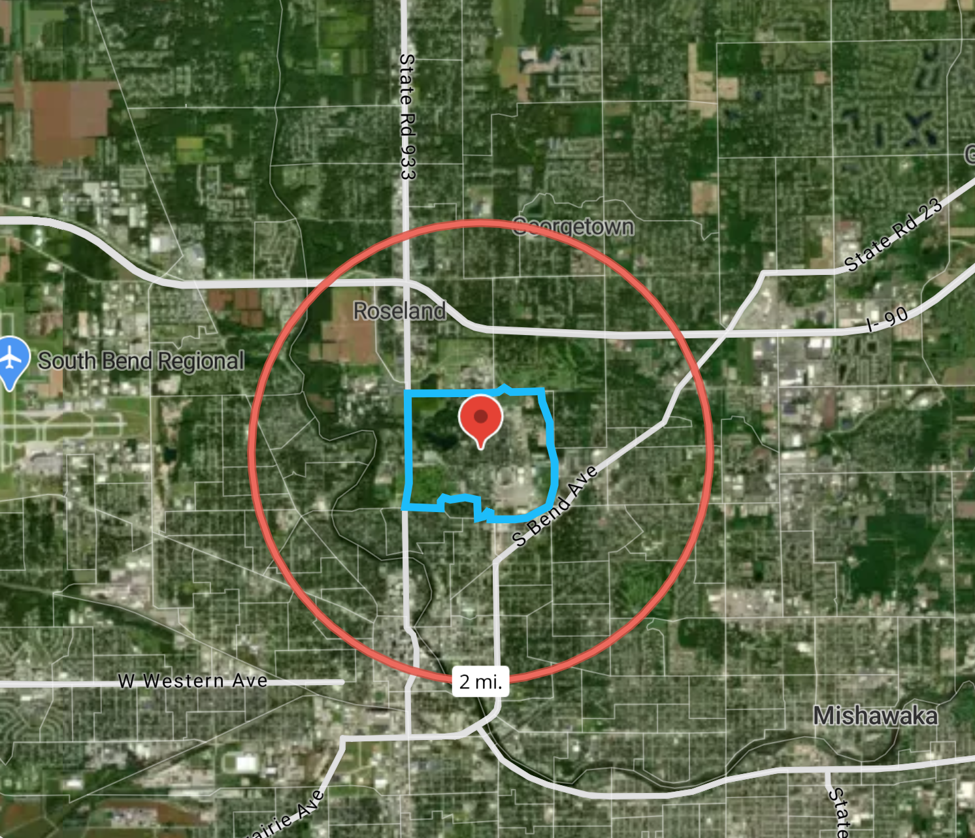

Figure 3

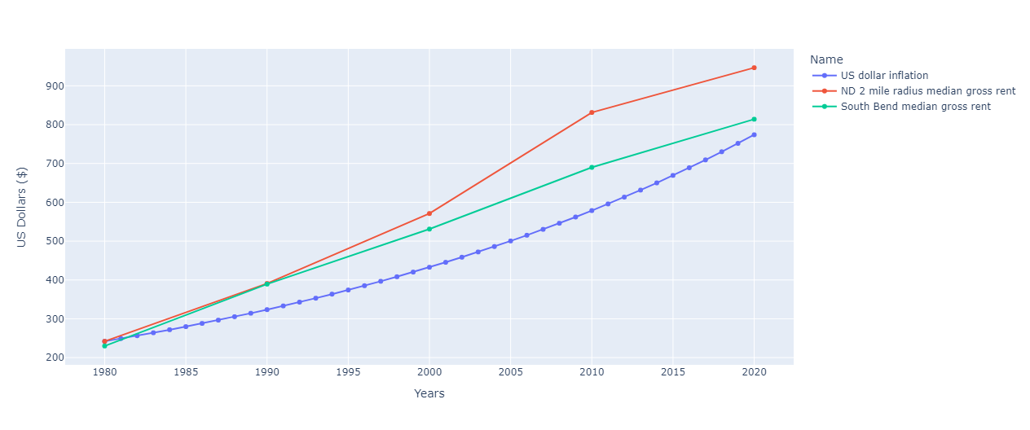

Figure 4

Figure 4 shows three lines, the green one shows the South Bend median rent, the red line shows the two-mile radius, as shown by the red circle in figure 3, of Notre Dame median rent, and the blue line shows the US dollar inflation normalized to the 1980 Notre Dame two- mile radius median rent. Around 2000, a separation started to show between the Notre Dame local median rental housing and the South Bend rental housing. This confirms that the area surrounding Notre Dame, supposedly due to the three housing pressures we listed, has been rising at a faster rate than that of South Bend.

In the past moving off campus was the most secure viable option for those students in search of affordable housing. With the recent increase in gentrification within 2 miles of campus and the emergence of the AirBnB market, the affordability of housing has dwindled. Where once you could find a place that was cheaper than room and board now there is an apartment complex where a studio apartment costs a minimum of $1,671 a month. Demand from Notre Dame parents and alumni purchasing housing near campus for seasonal housing also contributes to decreasing the amount of potential rental housing for students and Notre Dame employees. If we take into account that in 2017 the university changed its policy to now force students to stay on campus for 6 semesters we can see that students are now being put in a tough position if they aren’t on a full scholarship or can afford the full tuition.

Sources

American Community Survey 5-Year Data (2020)

American Community Survey 5-Year Data (2010)

Census 2000

Census 1990

Census 1980

<https://www.irishrealty.net/what-you-need-to-know-about-notre-dame-real-estate/>

<https://www.baymgmtgroup.com/blog/when-will-rent-prices-go-down/>

<https://financialaid.nd.edu/how-aid-works/cost-of-attendance/>

[Mobility Report Cards: The Role of Colleges on Intergenerational Mobility](https://opportunityinsights.org/paper/mobilityreportcards/)

[Cost of Living in Indiana](https://247wallst.com/state/cost-of-living-in-indiana/)